**DATA LIMIT WARNING**

Disclaimer: I have resorted to publishing my homework on GitHub, since Tableau Public seems to have a limit in terms of the amount of data and workbooks in the file. Please let me know if there is something, I can do to fix this. The rest of the assignment is shown below.

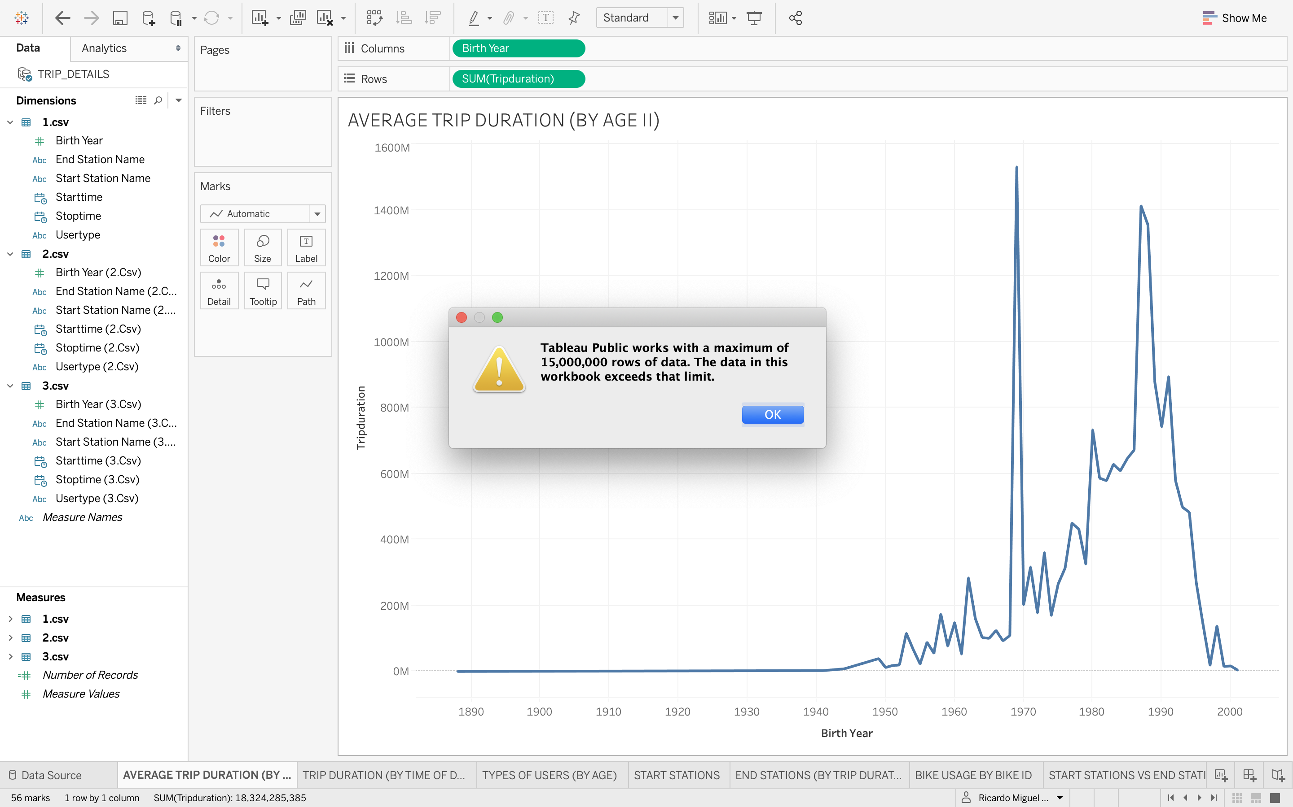

**STORY OF DATA (NYC CITI BIKE RIDERS)**

This first chart indicates a comparison of riders by age and their average trip durations. Not surprisingly, the younger generations (those born between the mid 70’s and the mid 90’s) seem to be the most active users in the platforms, probably due to their health and also due to their active lifestyles. However, there seem to be a series of outliers among those born in 1970, perhaps due to a miscalculation, an error while capturing the data, or even simply due to a real case where a person in that age group **did** ride significantly more than those in any other cohort!

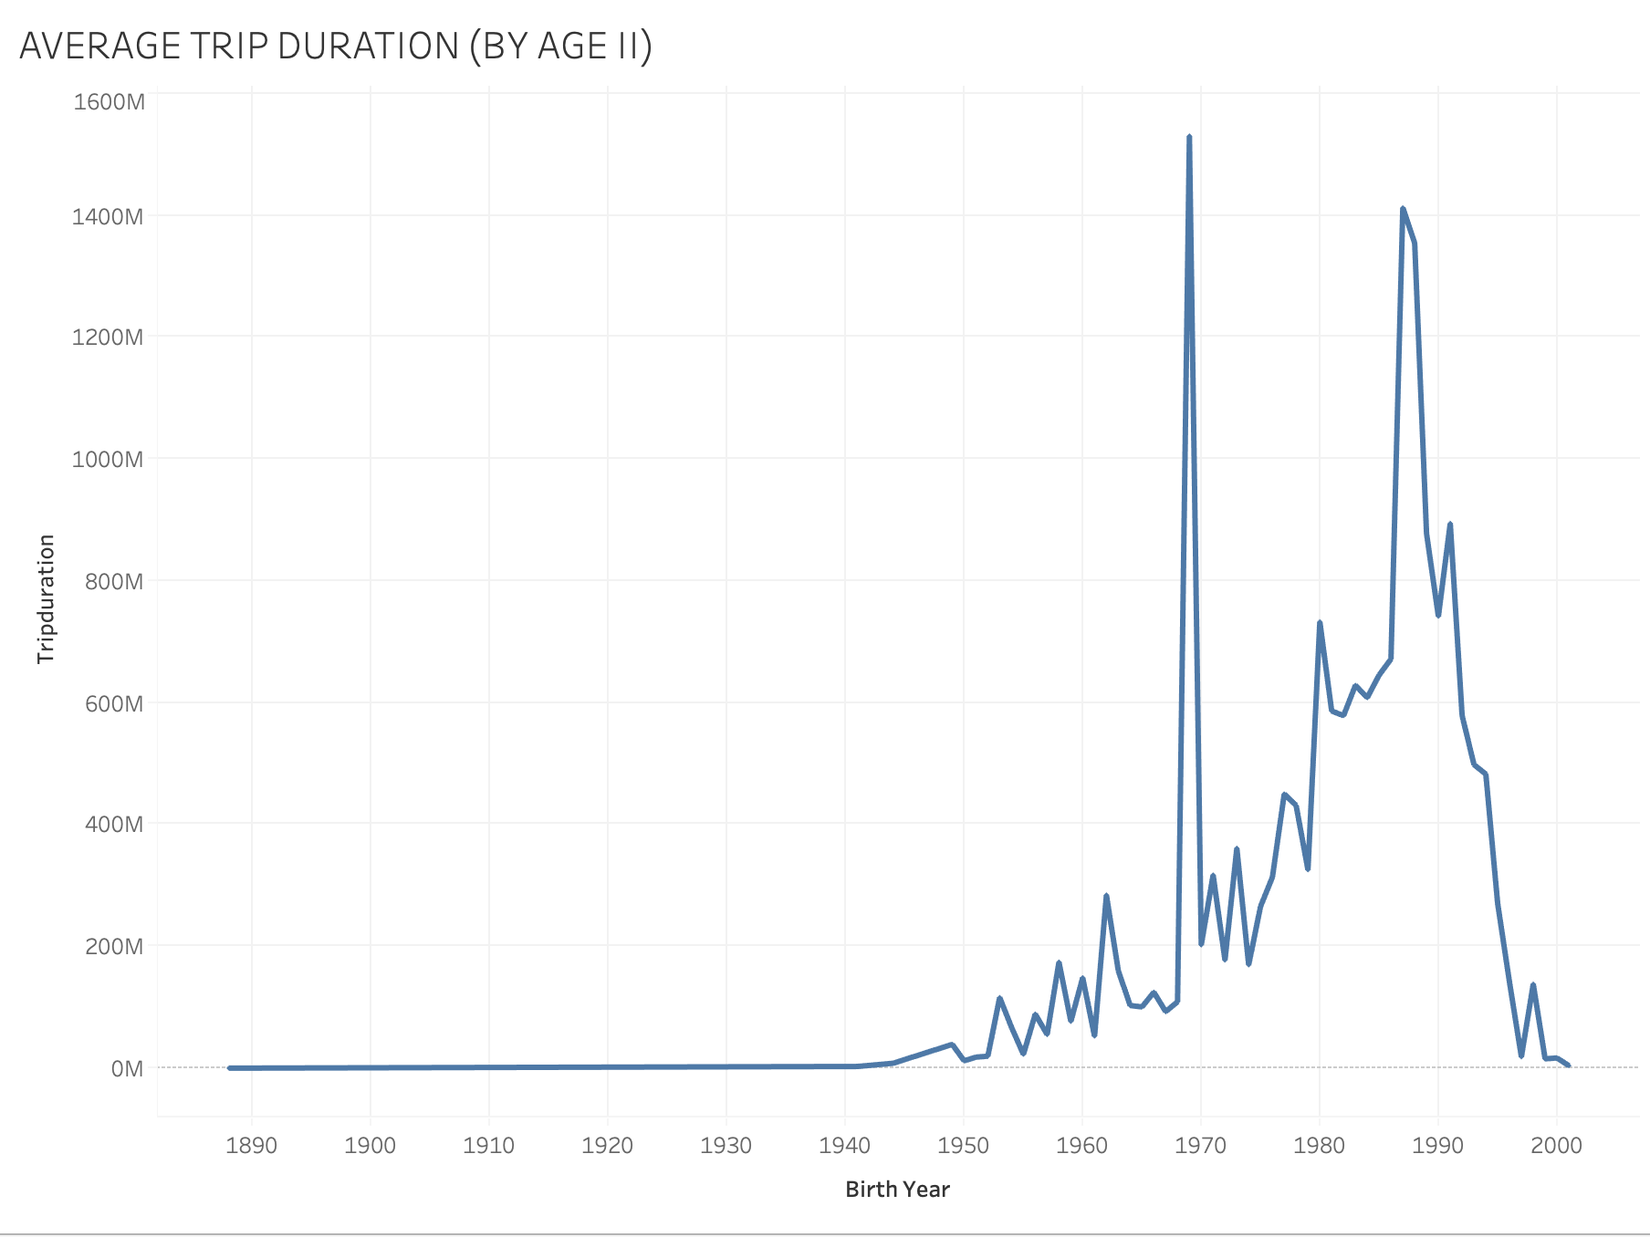

**TRIP DURATION BY TIME OF DAY**

This next chart shows the relation between the average trip duration of riders and the time of day of their trips. As one would expect, the early morning and the early evening are the busiest times, since these are when most commuters go to work, school and other assignments.

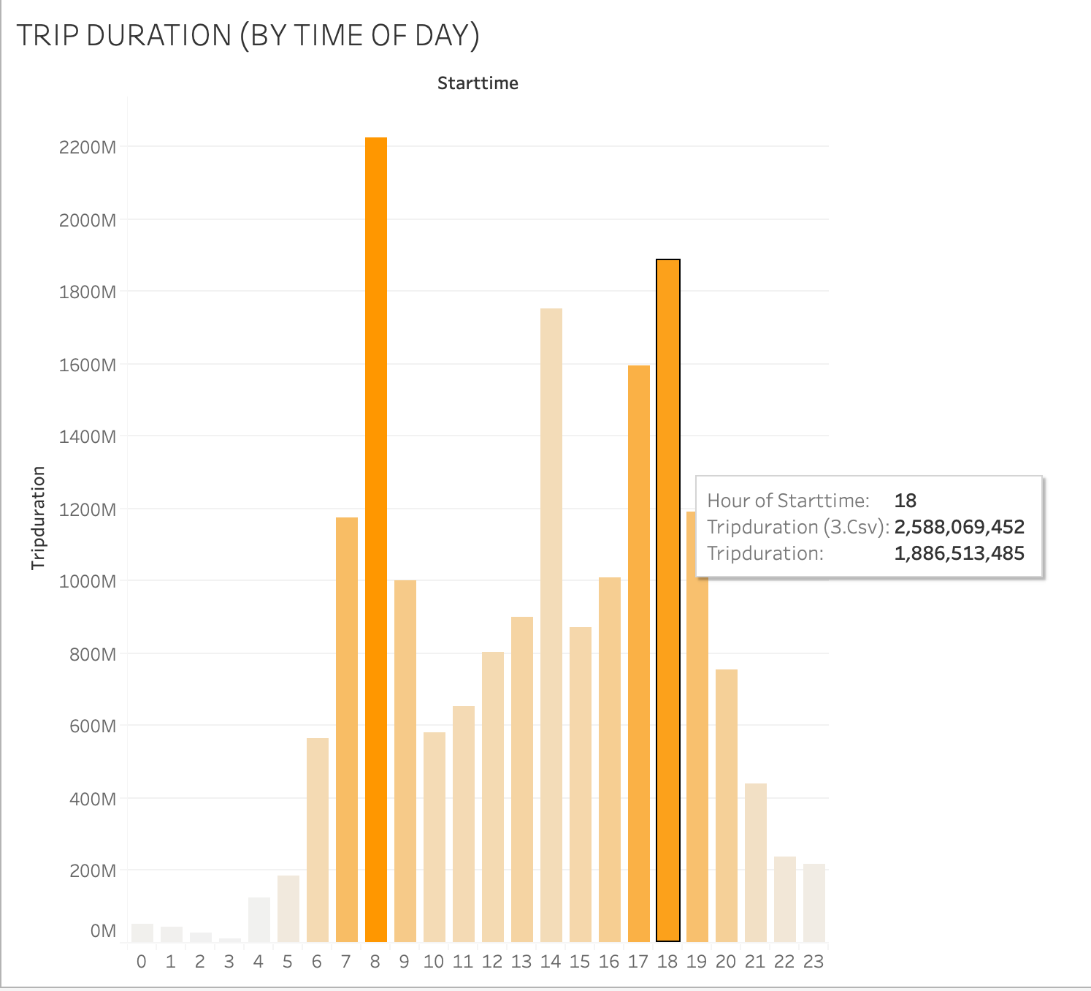

**TYPES OF USERS AND AGE**

The following chart shows all of the people distributed by age and also divided by the type of user in the service. Most of the users are recurrent subscribers, and as the previous charts show (for obvious reasons) there are almost no users born before 1950, and very few born after the year 2000.

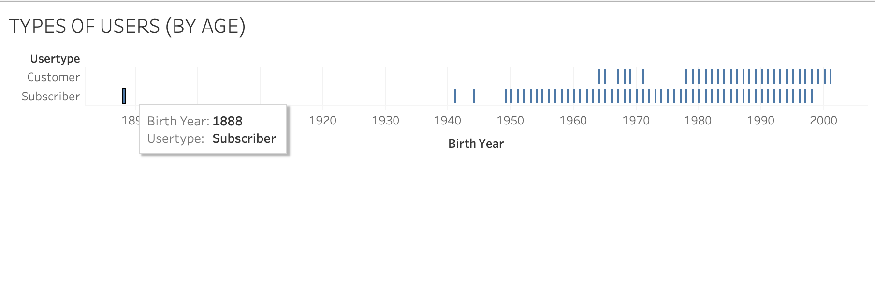

The next two charts show the relation between the starting and ending stations in New York City. Please note that the second chart has been configured, so that the dots appear larger or smaller depending on the duration of the trips ending in any given stations. As a funny observation, the east-side stations seem to be those where the trips which take the longest time finish.

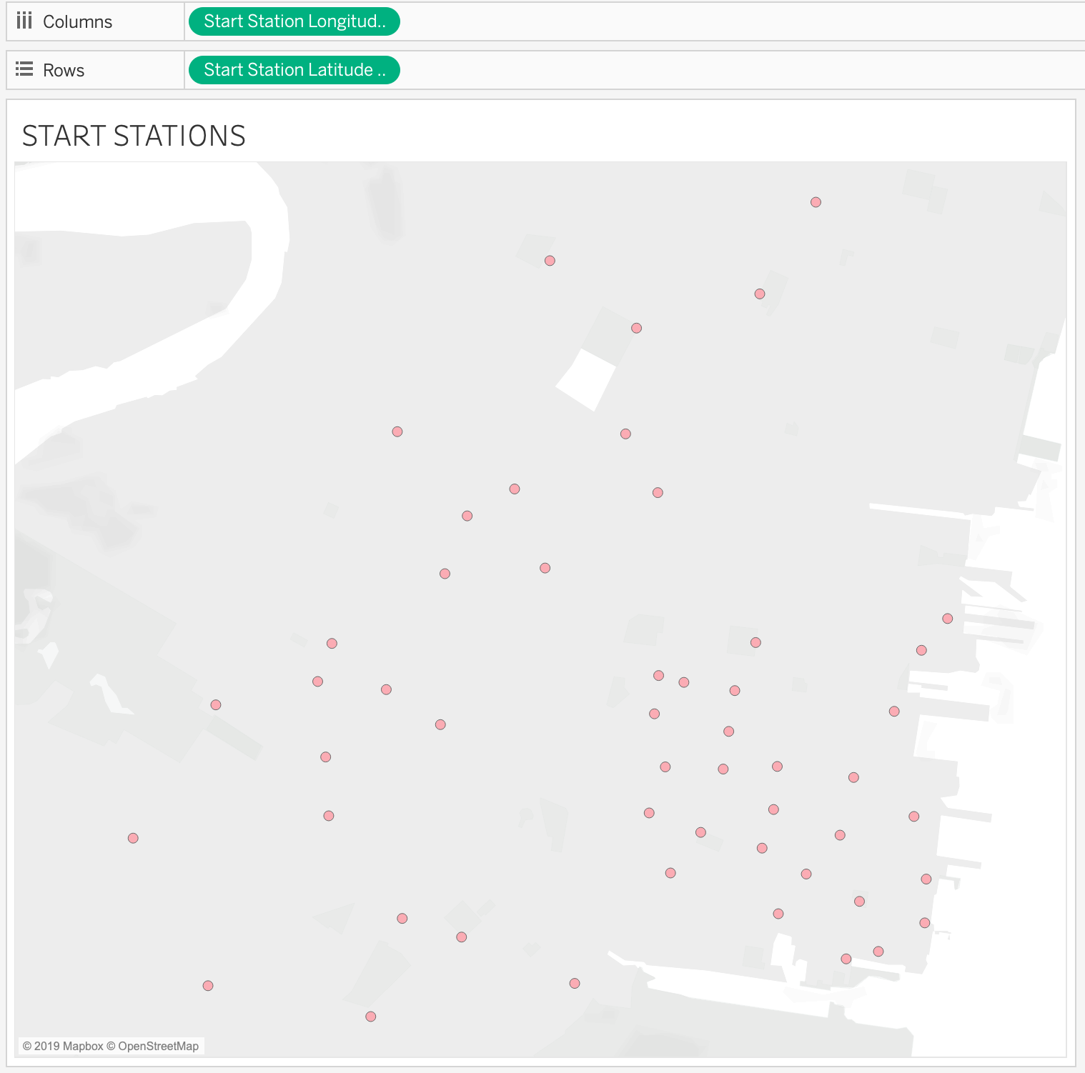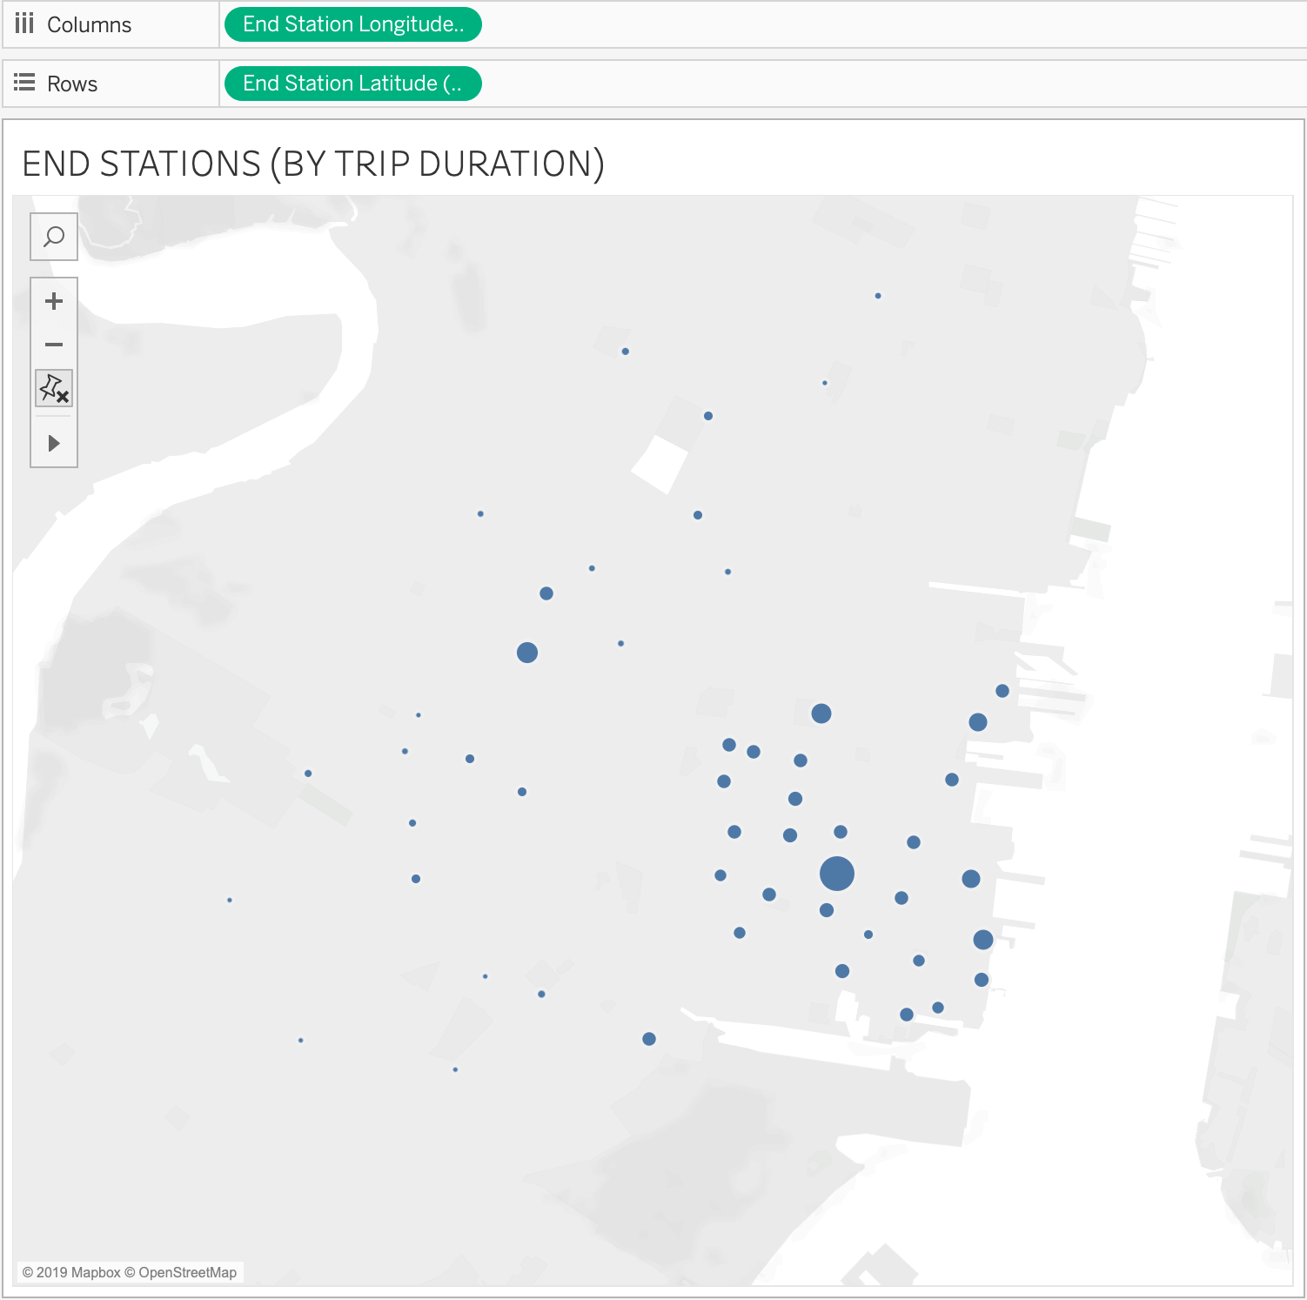

This other chart shows the ID’s of the most ‘popular’ bikes in the whole system. In other words, it shows the ID numbers for those bikes which are used the most, perhaps due to their location (any normal distribution would indicate that some bikes would tend to be used more than others, even if the choice of bikes happens to be random).

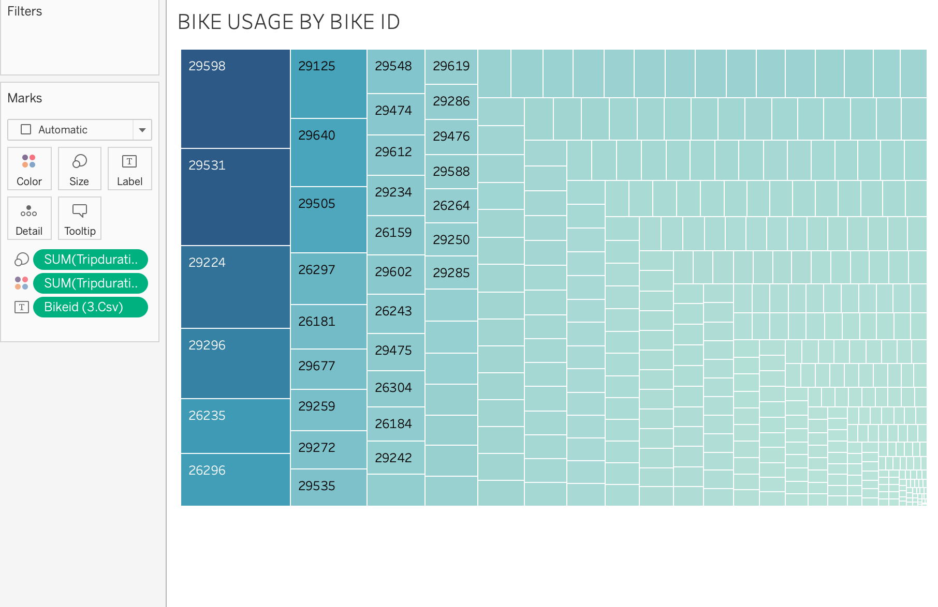

And last but not least, this chart below shows a detailed relation between the starting and ending stations for most trips. The most popular stations will be those where the most highlighted rows and columns intersect, such as the ‘City Hall’ station.

